Documentación

Regresión logística
- Logistic Regression Part I — Transformation of Linear to Logistic
- Gentle intro to logistic regression
- Understanding Logistic Regression
- Maximum Likelihood Estimation in Logistic Regression
- Logistic Regression: Explica cosas de L1 y L2
- The Intuitive Explanation of Logistic Regression
- Logistic Regression: A Detailed Overview from Scratch

Overfitting, validación , reducción de la dimensionalidad, datos entrada
- An overview of time-aware cross-validation techniques
  - Overfitting Issues and Optimization Techniques in Neural Network
- Overview Of 4 Model Validation Approaches to Mitigate Overfitting Problem
- 4 ways to Reduce Dimensionality of Data
- How to use K-fold Cross Validation with TensorFlow 2 and Keras?
- Bagging Classifier: Genera conjuntos de entrenamiento cogiendo subconjuntos de las columnas.
- Stop Using All Your Features for Modeling
- Handling Imbalanced Data
- Strategies and Tactics for Regression on Imbalanced Data
- Generate new samples non-linearly using Crucio TKRKNN.
- The Curse of Dimensionality and its Cure: Gráfica interesante de las dimensiones vs precisión
- Cross Validation - What, Why and How | Machine Learning
- Examples of Bias Variance Tradeoff in Deep Learning
- Nominal And Ordinal Encoding In Data Science!
- Overfitting Issues and Optimization Techniques in Neural Network
- Overfitting and Regularization in Machine Learning
- Batch Norm Explained Visually — How it works, and why neural networks need it
- Batch Normalization
- Examples of Bias Variance Tradeoff in Deep Learning: Buena explicación
- Bias
  - Introduction to biasness in AI — part 1
  - Biasness in AI— part 2
  - Biasness in AI- part 3
  - Biasness in AI — part 4

Métricas
- Why is cross entropy not a common evaluation metric for model performance?
- Confidence intervals for the Log Loss metric for model comparison?

Funciones de coste
- Aprendizaje automatico y las Metricas de regresión
- Aprendizaje automático de métricas de regresión (MSE)
- Machine Learning: Seleccion Metricas de clasificacion

Redes neuronales
- Vanilla Neural Network: Ejemplo básico en Python de una red neuronal
- Cost, Activation, Loss Function.Neural Network.Deep Learning. What are these?: Explicación de funciones de coste y de activación
- From Linear Regression to Neural Networks: Why and How: Interesan los dibujos
- Case Study: Is Spurious Correlations the reason why Neural Networks fail on unseen data?: Falla con una vaca en el desierto y una vaca en la nieve. Piensa que es un camello y un oso polar
- Paper Walkthrough — Matrix Calculus for Deep Learning (Part 1 / 2): Explicación del Jacobiano
- Batch:
  - Optimizers for machine learning
  - Effect of Batch Size on Neural Net Training: Muy bueno
  - All you need to know about Gradient Descent
  - Batch, Mini-Batch and Stochastic Gradient Descent for Linear Regression

Utilidades
- A Neural Network Playground: Simuladores de redes neuronales
- NN-SVG: Dibujar redes neuronales
- Neptune AI
- TensorBoard

Redes Neuronales Recurrentes, transformers, series de tiempo
- Predicción con Series de Tiempo - Una guía inicial
- Transformers Explained Visually — Not just how, but Why they work so well
- Feature Engineering of DateTime Variables for Data Science, Machine Learning, Python

Kaggle
- Kaggle. Credit Card Fraud Detection

Autoencoders
- Simplifying the concept of Autoencoders

Redes Convolutionales
- Basics of Convolutional Neural Networks — Stride and Pooling: Explica las 2 partes de una reco convolicional: Stride y Pooling
- Variational Autoencoders Simply Explained
- Understanding Convolutions by hand vs TensorFlow
- Isometric Drawing Tool

AutoML
- A Quickstart Guide to Auto-Sklearn (AutoML) for Machine Learning Practitioners
- Bayesian Hyper-Parameter Optimization: Neural Networks, TensorFlow, Facies Prediction Example
- Hyperparameter Optimization with the Keras Tuner, Part 2
- 10 Hyperparameters to keep an eye on for your LSTM model — and other tips
- Hyperparameter search using Bayesian Optimization and an Evolutionary Algorithm
- How to Use Horovod’s Large Batch Simulation to Optimize Hyperparameter Tuning for (Highly) Distributed Training
- Teorema de Bayes
  - Viendo la Teoría - Inferencia Bayesiana
  - ¿Cómo funciona la inferencia bayesiana?
  - Exploring Bayesian Optimization: Muy buena explicación de la optimización Bayesiana
  - La estadística detrás del rescate de la bomba de Palomares

Pipelines , MLOps
- Towards MLOps: Technical capabilities of a Machine Learning platform
- Exponer Modelo de clasificación Mediante Tensorflow y FastAPI
- Write and train your own custom machine learning models using PyCaret
- Monitoring Machine Learning Models
- Easy Benchmarking of Long-Running Programs
- Colab + Vs Code + GitHub + Jupyter (Perfect for Deep Learning)
- Guardando y Serializando Modelos con TensorFlow Keras

Gráficos
- Change Axis Labels, Set Title and Figure Size to Plots with Seaborn
- 7 Open Source Libraries for Deep Learning Graphs
- The Bokeh Visualization Library
- graphext
- Altair: Declarative Visualization in Python

Correlación
- Neural Networks fail on data with Spurious Correlation
- What is MultiCollinearity and how to resolve it?: Ejemplo de correlación
- Pearson and Spearman Rank Correlation Coefficient — Explained
- Covariance, Correlation and R-Squared Explained with Python
- Correlation in Statistics
- When To Use Spearman Correlation?

Estadística
- Fundamentals Of Statistics For Data Scientists and Analysts
- Basic Statistics for Data Science
- Probabilidad y Estadística con Python
- To Err is Human: What are Type I and II Errors?: Foto que explica muy facilmente los errores de tipo I y tipo II
- Scatter Plots In Data Analysis: La importancia de los Scatter Plots
- Anomaly Detection Techniques
- Bar Chart or Histogram?
- Situación 179: Prácticas de BIOMEDICINA
- Qué es la Paradoja de Simpson y por qué va a ser muy útil para entender los próximos meses de pandemia
- Regresión lineal
  - Linear Regression Assumptions: Que se asume para que una regresión linear se pueda realizar.
  - Probabilistic interpretation of linear regression clearly explained: Explica que el error sigue una distribución y el ½
- Distribuciones
  - The Benefit's Of Central Limit Theorem: Explicación de la utilidad de la distribución normal
  - Related Probability Distributions: Explicación de 3 distribuciones.
  - Visualizing Continuous distributions from SciPy: Imagen con muchas distribuciones.
  - Distribution Analyser: Información sobre distribuciones y si se ajustan a los datos
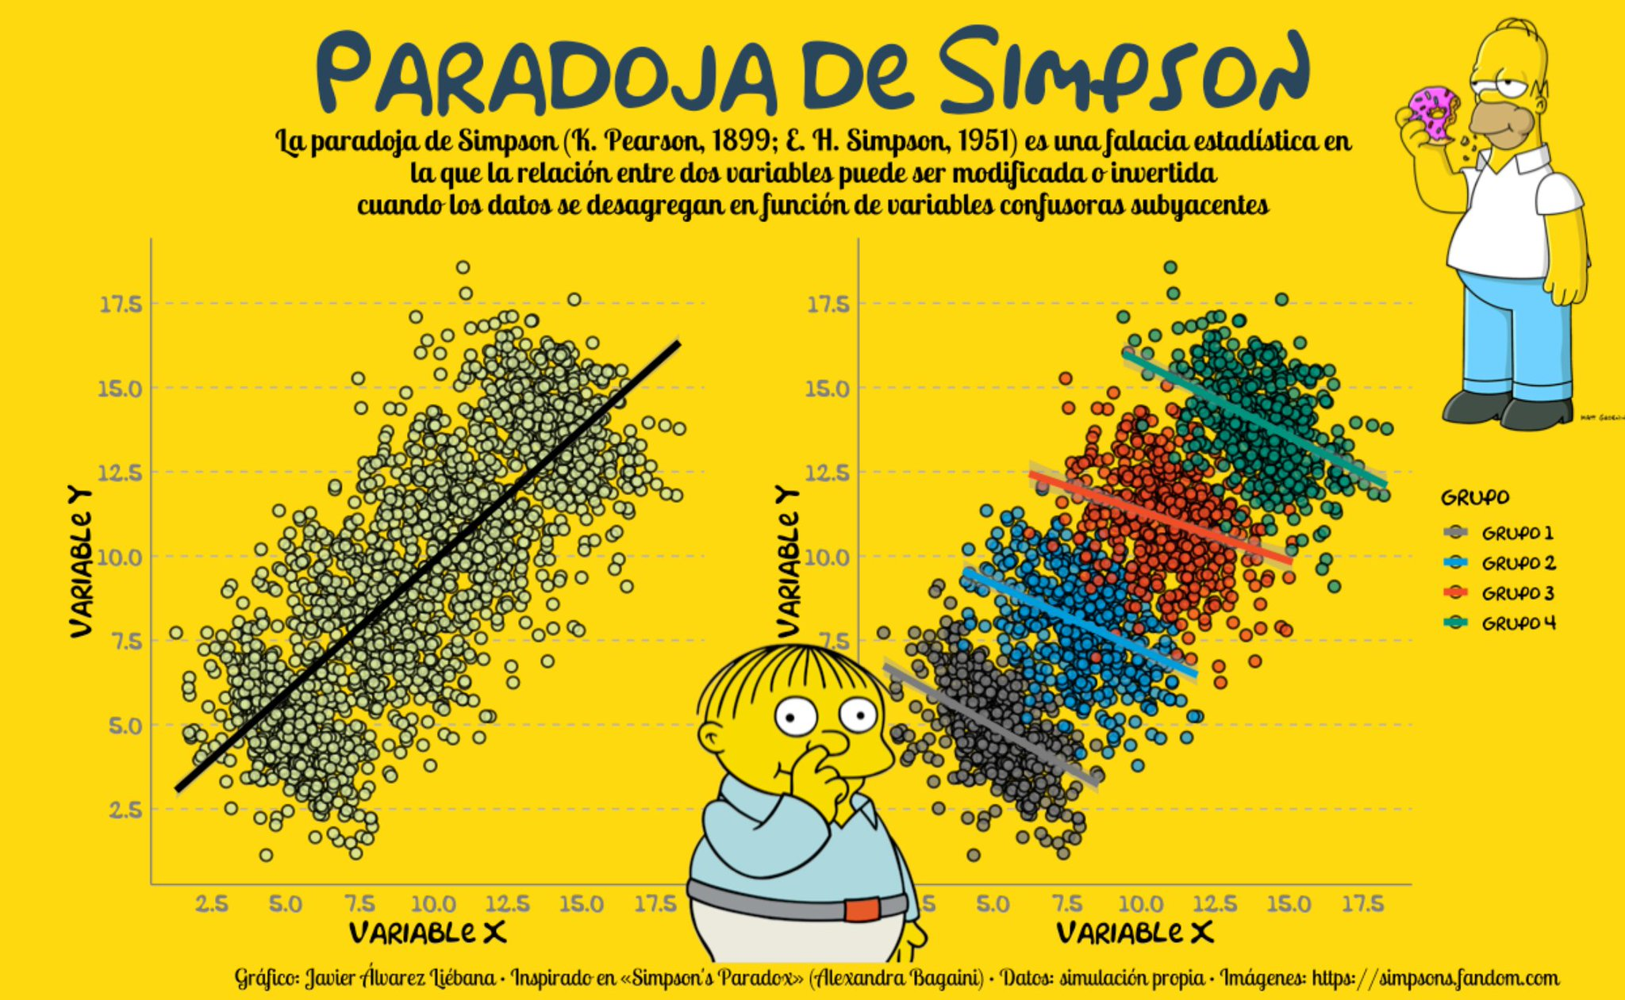

Matemáticas
- A Beginner’s Guide to Linear Algebra for Deep Learning:Escalares, vectores, matrices y tensores
- Paper Walkthrough — Matrix Calculus for Deep Learning (Part 2 / 2)
- Some Maths Resources to Help You in Your ML Journey

TensorFlow Avanzado
- Let’s Create Tensors like NumPy Arrays
- Linear Algebra with TensorFlow: Ejemplos de cálculos con TensorFlow en vez de usar numpy
- Creating and Training Custom Layers in TensorFlow 2
- Creating custom Loss functions using TensorFlow 2
- Creating Custom Activation Functions with Lambda Layers in TensorFlow 2
- 3 Keras Design Patterns Every ML Engineer Should Know

Natural Language Processing
- Natural Language Processing (NLP) for Semantic Search

EDA
- Imputing Missing Data Using Sklearn SimpleImputer
- Everything You’ve Ever Wanted to Know About Exploratory Data Analysis (EDA) Part — 1
- Exploratory Data Analysis On Haberman’s Cancer Survival Data set
- Making Your First Kaggle Submission
- Rapid-Fire EDA process using Python for ML Implementation
- Data Pre-Processing in Machine Learning with 🐍+Notebook
- How to Estimate Vaccine Efficacy Using a Logistic Regression Model
- How to find the best performing Machine Learning algorithm
- How I solved Kaggle’s April 2021 tabular competition
- Preprocessing data for data science (Part 1)
- Data Pre-Processing in Machine Learning with Python and Jupyter
- Exploratory Data Analysis : Iris DataSet
- Step by Step Guide to Build a Logistic Regression Model in Python
- Beginners guide to stock prediction using LSTM.
- Exploratory Data Analysis on Meteorological Data using Python
- Exploratory Data Analysis(EDA) y Exploratory Data Analysis(Part 2)
- Concrete Strength Modeling with 5 Machine Learning Algorithms
- Solve Machine Learning Problems
  - Solve Machine Learning Problems: EDA (part-1)
  - Solve Machine Learning Problems: Hypothesis Testing (Part-2)
  - Solve Machine Learning Problems: Data Preprocessing(part-3)
  - Solve Machine Learning problems: Feature Selection (part 4)
  - Solve Machine Learning Problems: Dimensionality Reduction (part-5)
  - Solve Machine Learning Problems: Outlier Detection (part-6)
  - Solve Machine Learning Problems: Regression & Model Selection(Part -7)

Guías
- Nine Things I Learned About Machine Learning During UmojaHack Africa 2021
- Basics of Data Cleansing: Las 6 cosas que hay que hacer para limpiar los datos
- Data Cleaning Libraries In Python: A Gentle Introduction
- 10 Deadly Sins of ML Model Training
- Data Analytics- Introduction: Tipos de análisis de datos
- Getting Started with Data Science with Python (Part-1): Que es la ciencia de datos
- Top 7 Feature Selection Techniques in Machine Learning
- The Top 25 Python libraries for Data Science
- Life Cycle Of Data Science Projects!

Libros online
- Dive into Deep Learning. (2021)
- Mathematics for Machine Learning-Ed. Cambridge University Press (2020)
- The Elements of Statistical Learning Data Mining, Inference, and Prediction-Ed Springer (2017)
- Deep Learning-Ed. MIT Press (2016)
- Neural Networks and Deep Learning-Ed Determination Press (2015)
- Pattern Recognition and Machine Learning-Ed. Microsfot Press (2006)

Compendios
- 58 Resources To Help Get Started With Deep Learning ( In TF )
- Guía rápida de IArtificial.net
- Distill — Latest articles about machine learning: Papers muy buenos sobre IA. Tienen mucho nivel.
- The Complete Reference to Data Science (ML/AI) and Related Concepts
- Important Links of Articles in Data Science and Deep Learning
- CS 189/289A Introduction to Machine Learning: Curso de IA de la universidad de Berkeley

Humor
- extrapolar

Python
- Charla: "Python packaging: lo estás haciendo mal"
  - Video de la charla:
  - Diapositivas
- Creating PEP 561 compatible packages
- How to make a Python package
- Installing Anaconda for Windows 10/8/7
- Visual Studio IntelliCode
- Google Colaboratory: Make Google Colaboratory GPU session wait for you.
- Google Colab
- How to Efficiently Load Image Datasets into Colab from Github, Kaggle and Local Machine
- 8 Tips and Tricks for Working with Large Datasets in Machine Learning
 | - Estructura de ficheros: https://github.com/drivendata/cookiecutter-data-science
- Poetry

Hardware
- DGX A100 : Universal System for AI Infrastructure | NVIDIA
- NVIDIA DGX Station A100 datasheet


